**RESTFul API using Swagger YAML**

by:

Richa Varshney

**Table of Contents**

**Introduction** 3

**How to create a YAML?** 4

**How to use Swagger YAML in a project?** 5

# **Introduction**

The Swagger spec provides a way to describe an API using a specific JSON or YAML schema that outlines the names, order, and other details of the API.

The interactive API documentation is generated by the Swagger file is minimal. It shows the resources, parameters, requests, and responses. However, it does not provide any other detail about the implementation.

It has following features:

* Swagger generates an interactive API console to quickly learn about and try the API.
* Swagger generates the client SDK code which can be implemented on various platforms.
* Swagger has a strong community with helpful contributors.

For better understanding of consumers, YAML can be converted to HTML, which provides a view about the API.

# **How to create a YAML?**

Since YAML follows a strict guidelines regarding its structure. It is suggested to use an editor provided by Swagger itself for the documentation of an API.

The [Swagger Editor](http://editor.swagger.io/#/) can be used to create YAML, which is an online editor that validates your YAML-formatted content against the rules of the Swagger specifications. YAML is a syntax that depends on **spaces** and **nesting**.

In addition to Swagger Editor, [YAMLLint](http://www.yamllint.com/) can also be used to validate the structure of an API, which highlights the problem areas if present.

The below link consists of a set of examples which can be referred to help in creating a well-structured YAML.

<https://github.com/OAI/OpenAPI-Specification/tree/master/examples/v2.0/yaml>

# **How to use Swagger YAML in a project?**

The below mentioned steps should be followed while using YAML to generate an API within a project.

1. Place YAML file and its corresponding HTML file in java resources folder
2. Add an open source plugin “swagger-codegen-maven-plugin” provided by “org.zalando.maven.plugins”

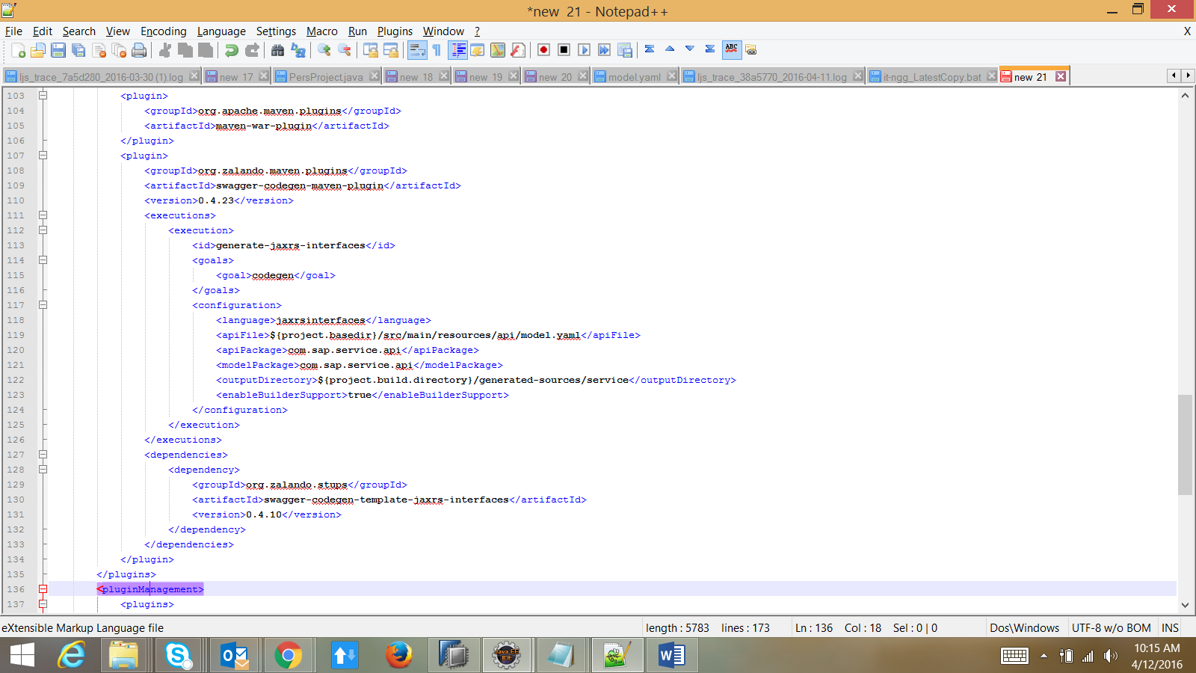

This plugin will take care of generating an API’s prototype by using the YAML (placed inside resources folder), which can be further extended to implement the service based on the requirement.

The prototype consists of several annotations which defines the basic behavior of the service.

Eg. PATH, GET, POST, PUT, DELETE and so on.

1. Add the missing dependencies:
   1. swagger-annotations
   2. swagger-jersey-jaxrs
   3. jersey-media-multipart

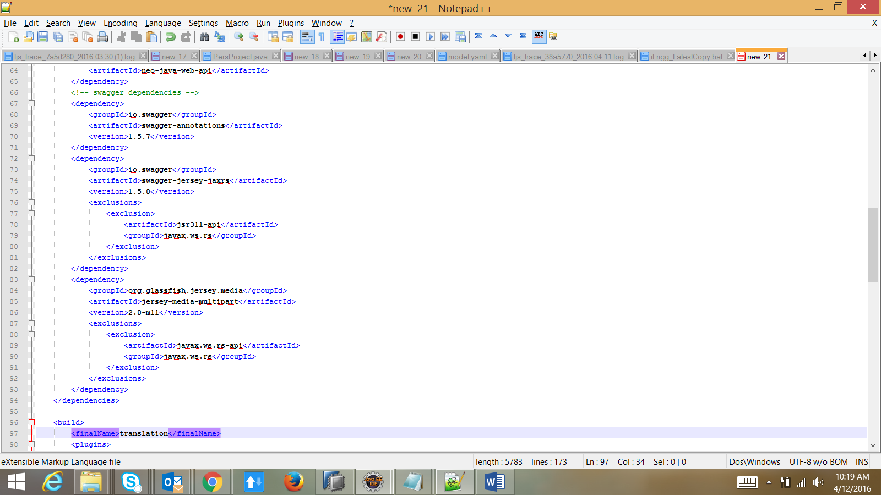

1. Build the project using maven, typically mvn clean install
2. The build command will generate a prototype
3. Once after getting the basic prototype of the API, it can be implemented in a class based on the requirement.